- Untar the distribution into a publicly available folder in apache. tar –xzvf iep-ipp_x.x.x.tar.gz

- Ensure that the scripts have the correct ownership.

- Point your browser to the location you untar’d the distribution
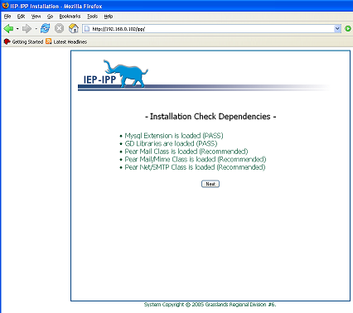
- Install dependencies if not present. On Red Hat/Fedora: ‘yum install php-mysql’, yum install ‘php-gd’, ‘yum install php-pear’.

- Install Pear Mail classes if you want email notifications: ‘pear install mail’, ‘pear install mail_mime’, ‘pear install net_smtp’.

- Setup a MySQL Database Username/Password. If you already have an IEP-IPP database. Uncheck ‘Populate Database’ otherwise leave it checked.
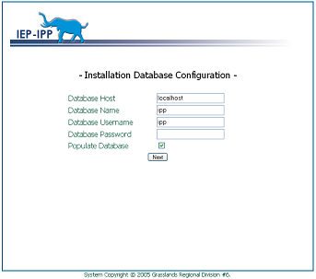
- Choose a title, the install location, and the address of your organization. These appear on the IEP/IPP’s. Put in your email SMTP server if you want to receive email notifications for IEP/IPP moves.
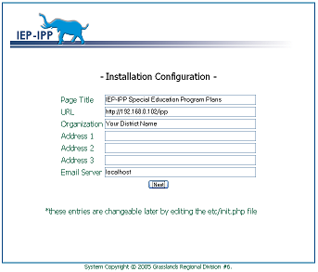
- Delete the ‘install’ folder on the server.

- Point your browser to the installation location. Log on to the system as ‘Admin’/’Admin’

- The default database is populated with two sample program plans, sample schools, and a sample user as an example. You can delete these.

- If you have problems let us know and maybe we can help: http://www.iep-ipp.com

